Employee Qualification Management

Given the following database model

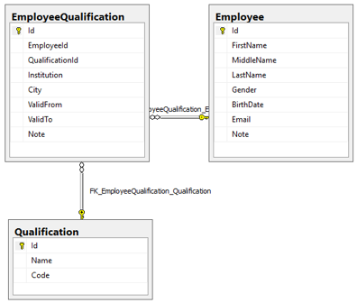

The script to create tables and test data is attached here: 

Please use the SQL Server Management Studio to create a database named “[EmployeeQualification]“, then execute the script above to create tables and test data.

Please create a simple web application with 2 pages that allows users to search employees and add/edit employees. The application must use the database above.

# [Search Employees] screen

**Layout and style**

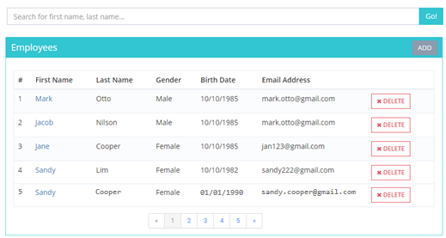

**Specs**

* Display all employees from database to employees grid at first open. Display 5 records per page.
* Allow user to sort the grid by **First Name** and **Last Name** column. Click on the grid header to sort.
* Allow user to search the employee by first name, last name or middle name; display the results to employees grid.
* When user clicks on a link in the First Name column, redirect user to [**Edit Employee Screen**] for selected employee.
* When user clicks on “ADD” button, redirect user to Add Employee Screen.
* When user clicks on “DELETE” button on the employees grid, display confirmation message “Do you want to delete this employee?”, if the user select OK, delete the employee and related qualifications from Database, then reload the grid.

# [Add/Edit Employees] Screen

**Layout and style**

**Add mode**

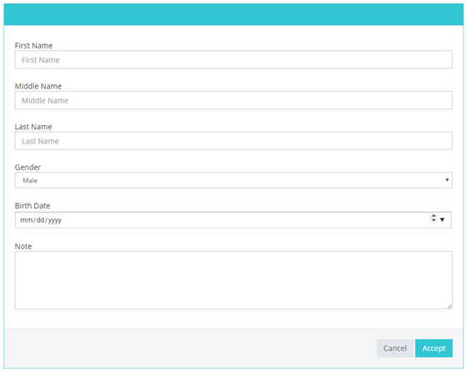

**Edit mode**

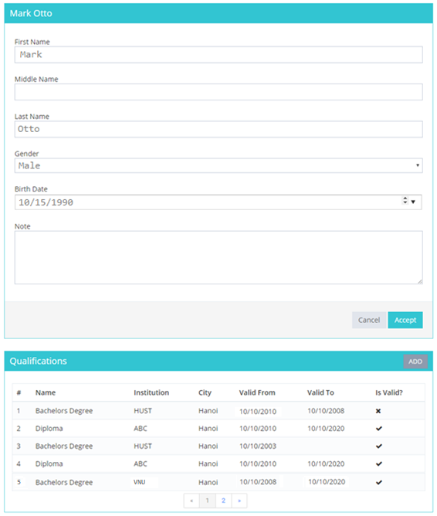

(*) The Qualifications section is available in Edit mode only.

**Specs**

**Employee section:**

* This screen allows user to edit the employee details or add new employee. It also allows user to add Qualification.
* The options for “Gender” dropdown list are “Male”, “Female”
* The required fields are: First Name, Last Name and Birth Date
* The “Cancel” button will redirect the user back to list employees screen.
* **In ADD mode**
  + Leave employee details item to blank, display “NEW EMPLOYEE” as title.
  + When user clicks the “ACCEPT” button, save the new employee information to Database, reload page.
* **In EDIT mode**
  + Display the employee information to employee details section then user can edit them. Display full name of employee (first name + middle name + last name) as title (e.g Mark Otto in the image above).
  + Display the employee’s qualifications to the qualifications grid section.
  + When user clicks the “ACCEPT” button, update the employee information to Database

**Qualifications section:**

* + In Qualifications grid, if the Valid To date greater than or equal Today, display “Is Valid?” as , else display 
  + When “ADD” button is clicked, open the following dialog to allow users to add qualification for current employee

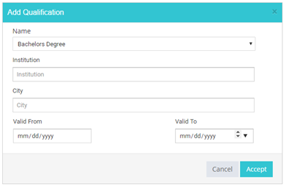

* + The required fields are: Name and Institution